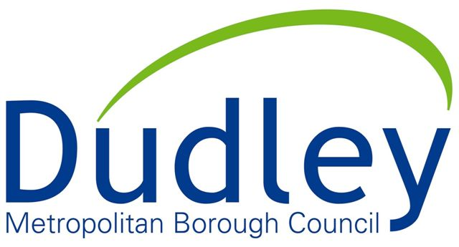

Health and safety policy

Sycamore Adventure believes that the health and safety of children, young people, parents and carers, volunteers, staff and visitors of the playground is of paramount importance. We recognise as employers and / or as persons in control of these premises, the need to make our setting both exiting and stimulating but also a safe and healthy place for people to use. Seeing both the importance of reducing risks, yet also the importance of risk taking for children and young people’s development, we take a risk-benefit approach to potential risks within the service. Health & Safety is everybody’s responsibilities and all concerns should be brought to the attention of the centre manager immediately. The centre manager is the health and safety representative on site.

Our play team have completed risk–benefit assessments both within the building and outdoor play space and surrounding the play menu offered at Sycamore Adventure in order to minimize the hazards and their associated risks, enabling all who use the adventure playground to play in a healthy and safe environment.

Sycamore Adventure is safety checked regularly by people both internal and external to the playground staff team. This includes daily and quarterly internal safety checks by Sycamore Adventure team and monthly & annual checks by professionals external to Sycamore Adventure team to ensure that the facilities are well maintained and safe for use.

A large cross section of the team are first aid trained to ensure that we always have first aid support on site. We aim to provide a rapid response to any accidents or injuries on site.

In order to provide both a safe yet exciting service, we adhere to the following procedures.

- A designated trained member of staff is responsible for monitoring health and safety, (Ella Blewitt, Play Service Manager)
- They are competent to carry out these responsibilities following extensive health and safety training and regularly updating their knowledge and understanding.
- A large percentage of paid workers are play work qualified, with specific modules completed on risk benefit assessments and dynamic risk assessment. They play a significant role in maintaining a safe environment for children’s play and responding to risk taking on the playground.
- Health and safety is covered as part of the centre’s induction process with in house training provided which highlights the importance of health and safety to new staff and volunteers.
- Health and safety is discussed at every team meeting and supervision.
- Risk benefit assessments are undertaken for the environment, for the play menu and for all centre events to ensure a safe working environment and practices. These are reviewed annually by the play service manager. Any new equipment / structures are risk assessed before being opened for public use.
- Accessible signage will be used around the centre and at satellite locations to communicate instructions or general information which will aim to minimise risk (e.g. fire evacuation procedures).
- Daily checks are completed and these cover health and safety to ensure that all areas of service are safe for use.
- Weekly in house checks are completed to ensure that lifting and handling equipment works correctly, fire systems are operating as required, there is no stagnant water on site and first aid kits are replenished.
- Lifting and handling equipment is checked by external organisations periodically (some items are annual checks. Others are once every quarter).
- Similar checks are held by external organisations on water / gas / electricity / fire fighting equipment / alarm systems to ensure everything is operating as required.
- If any of these checks flag up issues of health and safety, a decision will be made as to whether this area / the centre will need to be closed following a risk assessment taking place. Damages will be reported immediately and repairs will be implemented as soon as possible.
- The centre will receive a deep cleans from professional cleaners three times per week. It will also be kept clean by the play staff team in between cleaning visits. Close down and set up procedures ensure that the centre is fit for use by visitors.
- The playground will receive a monthly inspection from Greencare who will ensure that the facilities are safe for use. It will have an annual independent safety check conducted by an organisation external to the council (usually ROSPA). Sycamore Adventure Playground Manager will respond to any reported issues as a matter of urgency and direct maintenance jobs accordingly.
- Monthly, 6 monthly, annual and five year independent checks are completed by external groups to ensure that all equipment used is safe (Greencare, water checks… monthly. Bullet lift, Kingswinford fire, alarm testing… 3 monthly, Zurich… 6 months, Playground inspection… annual, PAT testing… annual, Amey Tree inspection… every five years, last completed Nov 14).
- Any significant health and safety incidents or issues will be reported on the same day that they occur / are detected to Mike Morton (Principle Health and Safety Officer). Reporting will be completed by Ella Blewitt or Will Ganniclifft in his absence.
- Sycamore Adventure is covered by the council’s public liability insurance.
- Sycamore Adventure will ensure that during public access play sessions where children come without parents; there are always two members of staff in the building and two member of staff outside in the play space, to protect children and to protect staff. The staff team will keep within eye shot / ear shot of one another. Communication with the wider staff team will be maintained via walky talky.
- Accident books are reviewed to pin point specific areas where accidents occur. This will inform repairs, areas to supervise and modifications on site.
- A fire risk assessment has been conducted (March 2020) with all actions completed to reduce fire risks at Sycamore Adventure. Weekly checks of firefighting equipment take place (and are recorded). Fire drills are held at least twice per year. The council organise inspection of fire-fighting equipment and alarms throughout the year.
- A water hygiene risk assessment has been conducted (April 2020). The centre conduct a series of checks on water inside and outside of the building to ensure water safety is of a high standard. External organisations also conduct water checks to ensure that the site is safe for children.
- A defibrillator has been installed at the front of the building to aid the adventure playground and the local community to preserve life.
- We will have regular reviews of the facilities at Sycamore Adventure in order to maintain a safe yet stimulating environment for children and young people who attend the centre.
- The staff team will listen to the views of users of the service with regard to health and safety to support Sycamore Adventure to be an exciting but safe place to play.
- This policy will be reviewed annually, following changes to legislation or following any serious health and safety issues on site.
- All serious health and safety issues are reported as follows:

Procedure for reporting injuries or dangerous occurrences

Sycamore Adventure is committed to encouraging and promoting good health and dealing efficiently and effectively with injuries and dangerous occurrences. The adventure playground will have a first aider present at all times to deal with any such incidents.

Reporting accidents and ill health at work is a legal requirement. The reported information helps the Health and Safety Executive and local authorities to identify where and how risks arise and to identify serious accidents. They will then provide appropriate guidance and advice on how to reduce injury, ill health and accidental loss.

If you need to report any injury, disease or dangerous occurrence the following procedure should be followed:-

- Report the incident immediately to the senior staff member on site who will then inform the registered person.
- Complete an online accident report form the same day which will be sent to the H&S council’s Safety Officers, Mike Morton or Jane Locke (01384 817877/2287/ mike.morton@dudley.gov.uk / jane.locke@dudley.gov.uk).
- For further advice and guidance discuss the matter with Mike Morton, Principal Health and Safety Officer on 01384 817877 or refer to the RIDDOR leaflet / website: http://www.hse.gov.uk/riddor

